INVERSE MODELLING:

|  |  |  |
| --- | --- | --- |
|  | RMSE | Iterations to converge |
| Model 1 | 0.1556 | 227 |
| Model 2 | 0.0246 | 131 |
| Model 3 | 0.0145 | 45 |
| Model 4 | 0.0098 | 42 |

With input=exp(-x)

|  |  |  |
| --- | --- | --- |
|  | RMSE | iteration |
| Model 5 | 0.1519 | 214 |
| Model 6 | 0.0077 | 28 |

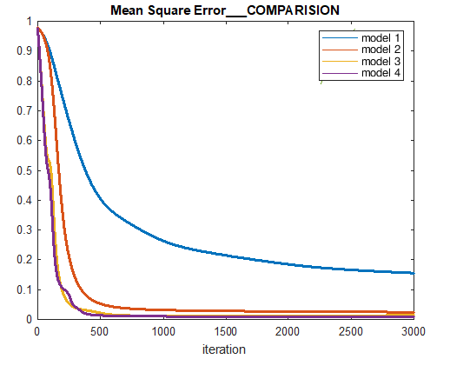

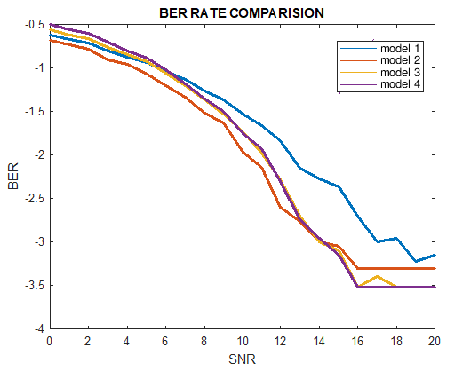

With input exp(-x)

